**User Activity Analysis Using SQL**

**Script:**

*CREATE TABLE users (*

*USER_ID INT PRIMARY KEY,*

*USER_NAME VARCHAR(20) NOT NULL,*

*USER_STATUS VARCHAR(20) NOT NULL*

*);*

*CREATE TABLE logins (*

*USER_ID INT,*

*LOGIN_TIMESTAMP DATETIME NOT NULL,*

*SESSION_ID INT PRIMARY KEY,*

*SESSION_SCORE INT,*

*FOREIGN KEY (USER_ID) REFERENCES USERS(USER_ID)*

*);*

*-- Users Table*

*INSERT INTO USERS VALUES (1, 'Alice', 'Active');*

*INSERT INTO USERS VALUES (2, 'Bob', 'Inactive');*

*INSERT INTO USERS VALUES (3, 'Charlie', 'Active');*

*INSERT INTO USERS VALUES (4, 'David', 'Active');*

*INSERT INTO USERS VALUES (5, 'Eve', 'Inactive');*

*INSERT INTO USERS VALUES (6, 'Frank', 'Active');*

*INSERT INTO USERS VALUES (7, 'Grace', 'Inactive');*

*INSERT INTO USERS VALUES (8, 'Heidi', 'Active');*

*INSERT INTO USERS VALUES (9, 'Ivan', 'Inactive');*

*INSERT INTO USERS VALUES (10, 'Judy', 'Active');*

*-- Logins Table*

*INSERT INTO LOGINS VALUES (1, '2023-07-15 09:30:00', 1001, 85);*

*INSERT INTO LOGINS VALUES (2, '2023-07-22 10:00:00', 1002, 90);*

*INSERT INTO LOGINS VALUES (3, '2023-08-10 11:15:00', 1003, 75);*

*INSERT INTO LOGINS VALUES (4, '2023-08-20 14:00:00', 1004, 88);*

*INSERT INTO LOGINS VALUES (5, '2023-09-05 16:45:00', 1005, 82);*

*INSERT INTO LOGINS VALUES (6, '2023-10-12 08:30:00', 1006, 77);*

*INSERT INTO LOGINS VALUES (7, '2023-11-18 09:00:00', 1007, 81);*

*INSERT INTO LOGINS VALUES (8, '2023-12-01 10:30:00', 1008, 84);*

*INSERT INTO LOGINS VALUES (9, '2023-12-15 13:15:00', 1009, 79);*

*-- 2024 Q1*

*INSERT INTO LOGINS (USER_ID, LOGIN_TIMESTAMP, SESSION_ID, SESSION_SCORE) VALUES (1, '2024-01-10 07:45:00', 1011, 86);*

*INSERT INTO LOGINS (USER_ID, LOGIN_TIMESTAMP, SESSION_ID, SESSION_SCORE) VALUES (2, '2024-01-25 09:30:00', 1012, 89);*

*INSERT INTO LOGINS (USER_ID, LOGIN_TIMESTAMP, SESSION_ID, SESSION_SCORE) VALUES (3, '2024-02-05 11:00:00', 1013, 78);*

*INSERT INTO LOGINS (USER_ID, LOGIN_TIMESTAMP, SESSION_ID, SESSION_SCORE) VALUES (4, '2024-03-01 14:30:00', 1014, 91);*

*INSERT INTO LOGINS (USER_ID, LOGIN_TIMESTAMP, SESSION_ID, SESSION_SCORE) VALUES (5, '2024-03-15 16:00:00', 1015, 83);*

*INSERT INTO LOGINS (USER_ID, LOGIN_TIMESTAMP, SESSION_ID, SESSION_SCORE) VALUES (6, '2024-04-12 08:00:00', 1016, 80);*

*INSERT INTO LOGINS (USER_ID, LOGIN_TIMESTAMP, SESSION_ID, SESSION_SCORE) VALUES (7, '2024-05-18 09:15:00', 1017, 82);*

*INSERT INTO LOGINS (USER_ID, LOGIN_TIMESTAMP, SESSION_ID, SESSION_SCORE) VALUES (8, '2024-05-28 10:45:00', 1018, 87);*

*INSERT INTO LOGINS (USER_ID, LOGIN_TIMESTAMP, SESSION_ID, SESSION_SCORE) VALUES (9, '2024-06-15 13:30:00', 1019, 76);*

*INSERT INTO LOGINS (USER_ID, LOGIN_TIMESTAMP, SESSION_ID, SESSION_SCORE) VALUES (10, '2024-06-25 15:00:00', 1010, 92);*

*INSERT INTO LOGINS (USER_ID, LOGIN_TIMESTAMP, SESSION_ID, SESSION_SCORE) VALUES (10, '2024-06-26 15:45:00', 1020, 93);*

*INSERT INTO LOGINS (USER_ID, LOGIN_TIMESTAMP, SESSION_ID, SESSION_SCORE) VALUES (10, '2024-06-27 15:00:00', 1021, 92);*

*INSERT INTO LOGINS (USER_ID, LOGIN_TIMESTAMP, SESSION_ID, SESSION_SCORE) VALUES (10, '2024-06-28 15:45:00', 1022, 93);*

*INSERT INTO LOGINS (USER_ID, LOGIN_TIMESTAMP, SESSION_ID, SESSION_SCORE) VALUES (1, '2024-01-10 07:45:00', 1101, 86);*

*INSERT INTO LOGINS (USER_ID, LOGIN_TIMESTAMP, SESSION_ID, SESSION_SCORE) VALUES (3, '2024-01-25 09:30:00', 1102, 89);*

*INSERT INTO LOGINS (USER_ID, LOGIN_TIMESTAMP, SESSION_ID, SESSION_SCORE) VALUES (5, '2024-01-15 11:00:00', 1103, 78);*

*INSERT INTO LOGINS (USER_ID, LOGIN_TIMESTAMP, SESSION_ID, SESSION_SCORE) VALUES (2, '2023-11-10 07:45:00', 1201, 82);*

*INSERT INTO LOGINS (USER_ID, LOGIN_TIMESTAMP, SESSION_ID, SESSION_SCORE) VALUES (4, '2023-11-25 09:30:00', 1202, 84);*

*INSERT INTO LOGINS (USER_ID, LOGIN_TIMESTAMP, SESSION_ID, SESSION_SCORE) VALUES (6, '2023-11-15 11:00:00', 1203, 80);*

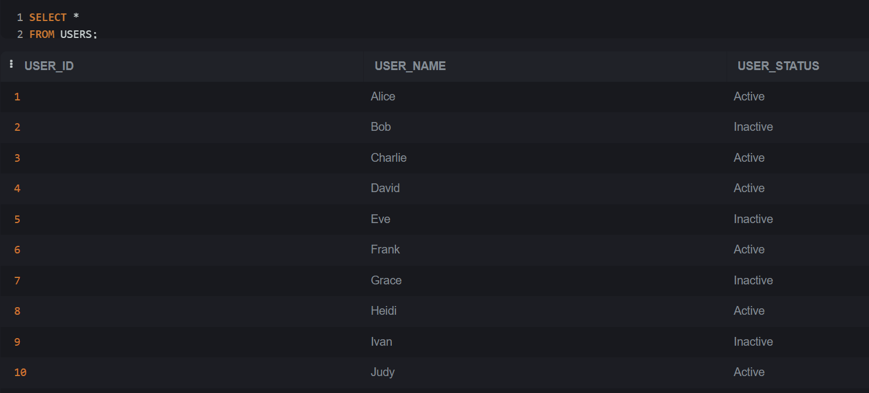

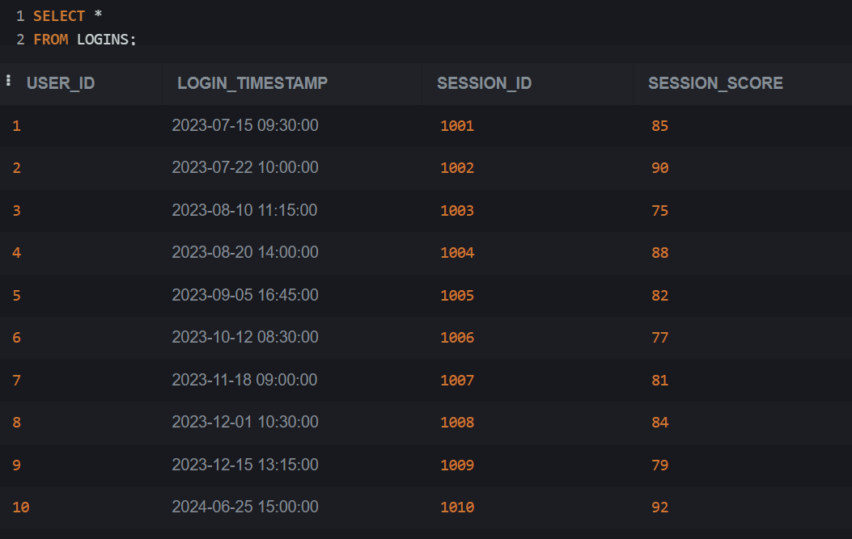

**Que 1 : Which users did not log in during the past 5 months?**

Today’s date – 2024-AUGUST-04

Past 5 months date – 2024-MAR-04

*SELECT user_id,MAX(login_timestamp)*

*FROM LOGINS*

*GROUP BY user_id*

*HAVING MAX(login_timestamp) < DATEADD(MONTH,-5,GETDATE());*

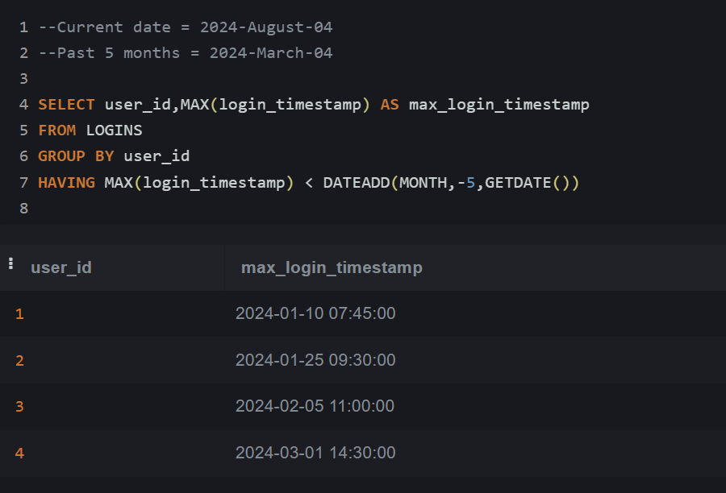

2ND Method:

*SELECT DISTINCT user_id, login_timestamp*

*FROM logins*

*WHERE user_id NOT IN(*

*SELECT user_id FROM LOGINS*

*GROUP BY user_id HAVING MAX(login_timestamp) >= DATEADD(MONTH,-5,GETDATE())*

*)*

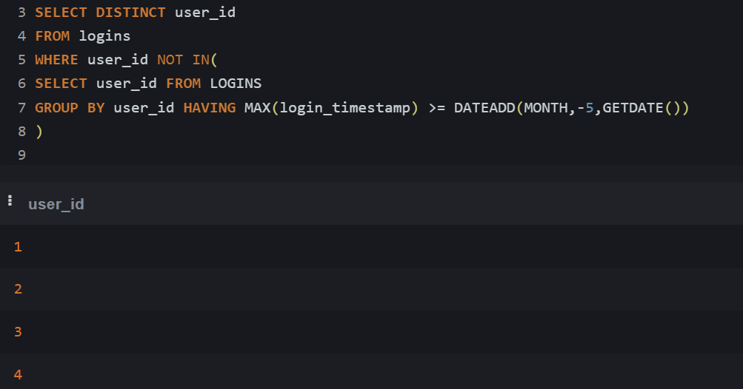

**Que 2) How many users and sessions were there in each quarter, ordered from newest to oldest?**

Return first day of the quarter, user count, session count

*SELECT*

*count(distinct user_id) as user_count,*

*DATETRUNC(quarter,MIN(login_timestamp)) AS First_Day_Of_Quarter*

*FROM logins*

*GROUP BY DATEPART(quarter, login_timestamp);*

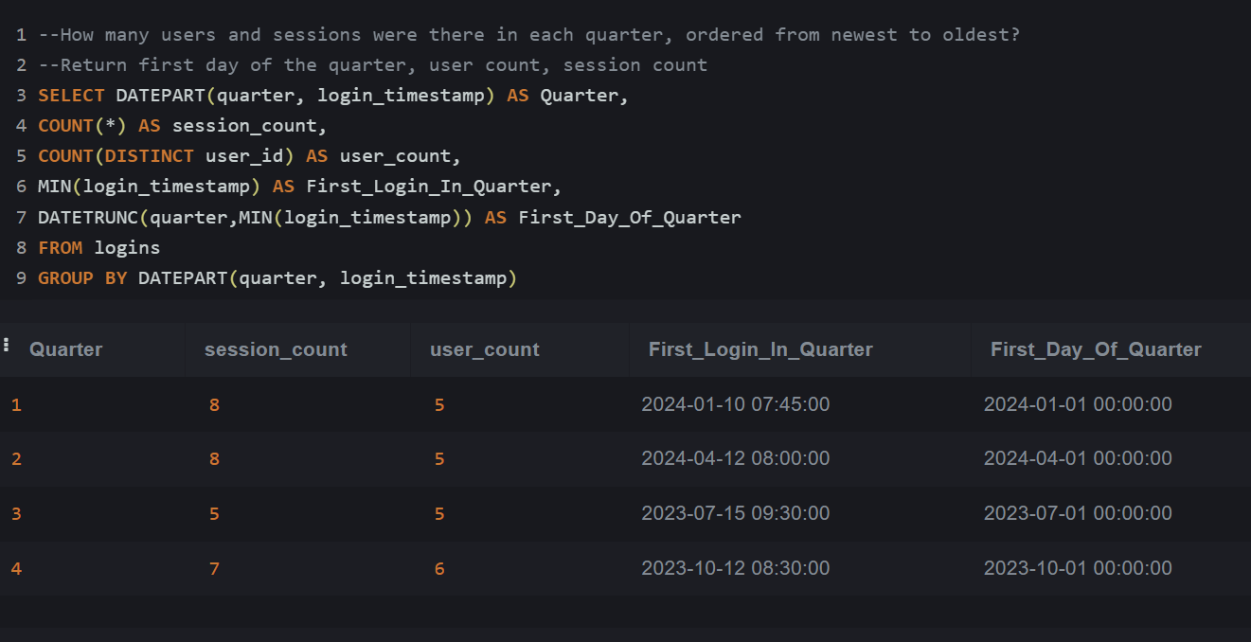

**Que 3) Which users logged in during January 2024 but did not log in during November 2023?**

*SELECT DISTINCT user_id FROM logins*

*WHERE user_id NOT IN(*

*SELECT user_id*

*from logins WHERE login_timestamp between '2023-11-01' AND '2023-11-30' --2,4,6,7*

*)*

*AND login_timestamp between '2024-01-01' AND '2024-01-31' --1,2,3,5;*

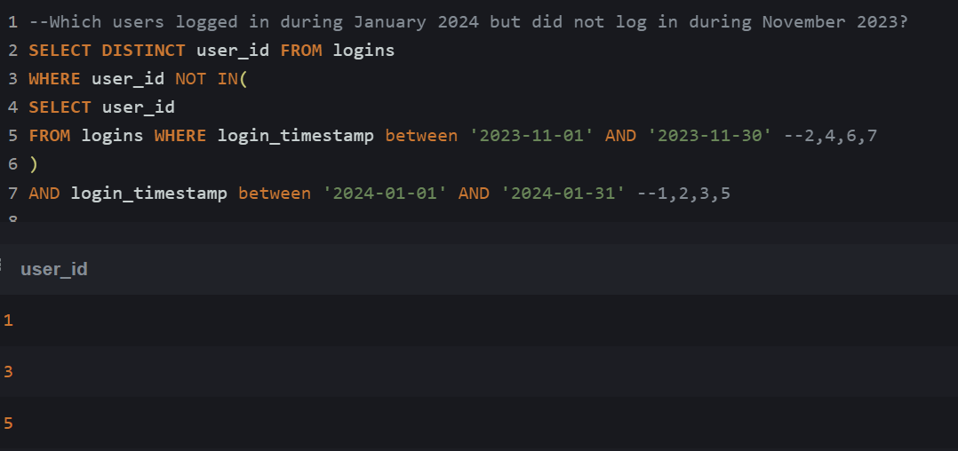

***Que4) What is the percentage change in sessions from the last quarter? Add to question 2 above***

--Return first day of the quarter, user count, session count, previous session count, percentage change

*with first_cte AS(*

*SELECT DATETRUNC(quarter,MIN(login_timestamp)) AS First_Day_Of_Quarter,*

*count(distinct user_id) as user_count,*

*COUNT(*) AS session_count*

*FROM logins*

*GROUP BY DATEPART(quarter, login_timestamp) )*

*SELECT *,*

*LAG(session_count,1) over(order by First_Day_Of_Quarter) AS previous_session,*

*((session_count - LAG(session_count,1) over(order by First_Day_Of_Quarter)) * 100*

*/ LAG(session_count,1) over(order by First_Day_Of_Quarter) ) AS Percent_change*

*FROM first_cte*

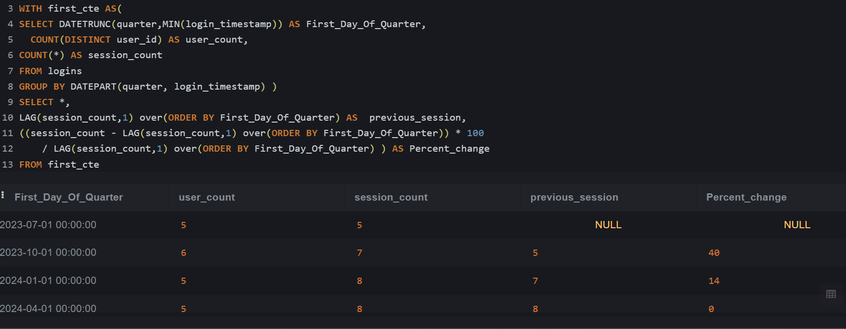

**Que 5) Which user had the highest session score each day?**

*WITH temp AS(*

*SELECT user_id, login_timestamp,SUM(session_score) AS score*

*FROM logins*

*GROUP BY user_id,login_timestamp*

*)*

*,temp1 AS (*

*SELECT *,*

*RANK() over( PARTITION by login_timestamp order BY score DESC ) AS rn*

*FROM temp*

*)*

*SELECT user_id,login_timestamp FROM temp1 WHERE* rn=1

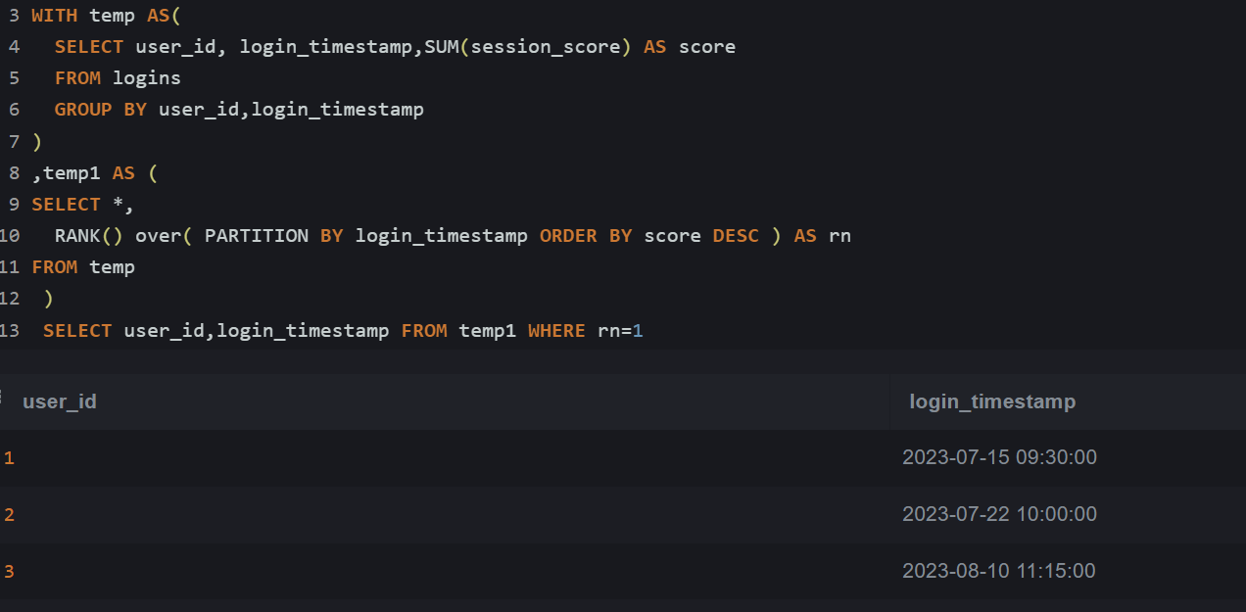

**Que 6) Which users have had a session every single day since their first login?**

*WITH temp AS(*

*SELECT user_id, min(login_timestamp) AS First_Login, MAX(login_timestamp) AS Last_Login, COUNT(session_id) as total_logins*

*FROM logins*

*GROUP BY user_id*

*),*

*temp2 AS(*

*SELECT user_id, total_logins,DATEDIFF(DAY, First_Login,Last_Login)+1 AS total_days*

*FROM temp*

*)*

*SELECT * FROM temp2 WHERE total_logins = total_days*

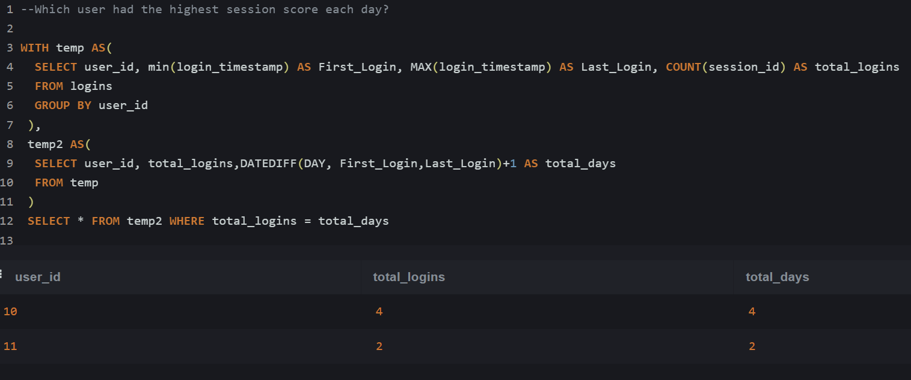

**Que 7) On what dates were there no logins at all?**

*WITH temp AS*

*(*

*select MIN(login_timestamp) AS first_login_date, MAX(login_timestamp) AS last_login_date*

*from logins*

*UNION ALL*

*select DATEADD(DAY,1, first_login_date) AS first_login_date, last_login_date*

*from temp*

*WHERE first_login_date < last_login_date*

*)*

*SELECT \**

*FROM temp WHERE first_login_date NOT IN (SELECT DISTINCT login_timestamp from logins)*

*option(maxrecursion 400)*

